Intro
In this essay I am going to talk about how Studio Ghibli movies inspired the game Ori and the blind forest, talk about the characteristics of each and include my own interpretation of how the game could be inspired by some unique aspects of Ghibli movies and how they compare in terms of shape, colour, lighting, composition, and detail. This will likely be focused on more mainstream Ghibli movies as it is easier to recognise where references are made to them and it is more likely that the reader has seen or heard of them.
Ori and the Blind Forest is a game created by Moon Studios, published by Microsoft and released in 2015. It follows the story of the main character, Ori, who is controlled by the player, a character called Naru, and an entity called ‘Sein’. The objective is to explore and find a way to restore the forest after it dies. The plot is heavily focused on nature and an imbalance in nature causing chaos, a theme explored in many Ghibli films possibly because in Japan, society is generally more mindful of nature and the environment.
Ghibli movies, also known as Miyazaki movies are well known animated Japanese movies directed by Hayao Miyazaki and are characterised by their visual appeal and painstaking detail in the design, animation and stories. The movies are incredibly diverse in the subject matter and they can range from realistic, tragic stories with focus on war and death, to cheerful, whimsical stories aimed at children. This greatly impacts the environments and aesthetic of each movie, but the art style is distinctive and references to specific movies in Ori and the Blind forest can be recognised due to the memorable scenes and character designs in the movies.
Lighting
Ori and the blind forest is a game focused heavily on visual appeal and movement in the same way that Ghibli focuses on these. One noticeable characteristic of Ori and the Blind Forest is the lighting and colour. Many scenes are illuminated by a direct light source, either as a light emitted from a character, element in the game, or moon and sunlight. It rarely relies on ambient light in a scene because this could create a dreary look. Ghibli tends to use light sources from varying places in scenes set at night, such as in glowing crystals in caves, fireflies, or fire, presumably to make the scene more interesting to look at despite being set at night and to aid the story in some cases. Using these unique light sources at night can create a dreamy, relaxed feel similar to Ori and the Blind Forest.
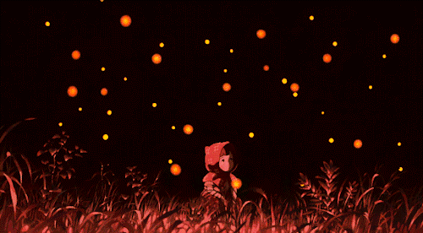

The lighting stands out in Ori and the Blind Forest because it is usually coming from something that wouldn’t realistically emit light, such as glowing trees, plants or spikes, either to add to the surreal aesthetic or to indicate mechanics to the player depending on the colour. Ghibli movies tend to use more believable light sources in order to keep the movies somewhat grounded in reality and to make the world more relatable to the viewer. In addition to this, Ghibli tends to build somewhat realistic environments even in surreal movies. One exception to this is a movie called Nausicaa of the Valley of the wind, which is referenced by Ori and the Blind Forest in the name of the level ‘Valley of the wind’. The movie has environments that appear less grounded compared to other movies, varying elements of nature and changing them to look fantastical and surreal, such as plants that appear to look like cat tails and coral reefs.
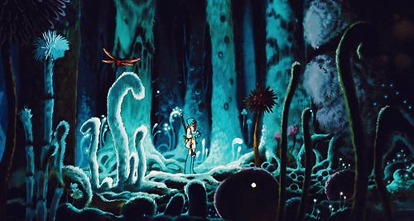
Character Design
Another similarity between the two is in the character design and the inspiration for each. For example, Naru. She appears to be a combination of the character Totoro and the character No-face from Spirited away, and the character Ori looks like Teto from Valley of the Wind although this is more likely to be coincidence. The scene below is a comparison between the game and Princess Mononoke.
Ori and the Blind Forest
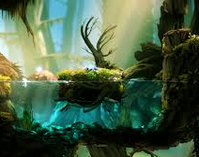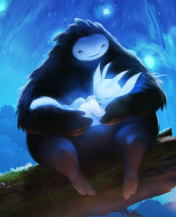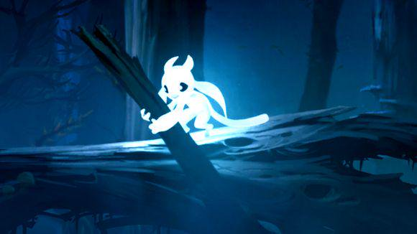
Ghibli
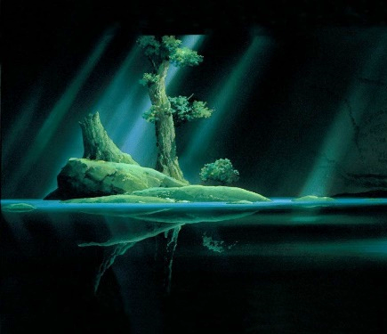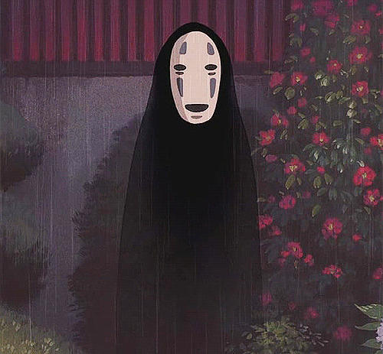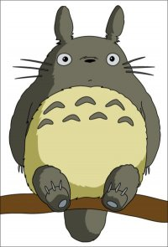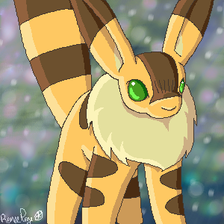

This character design is effective and helps convey a lot of about the characters just by looking at them. Characters like Naru look harmless and friendly because of the round shape of the body and people generally have a more positive association with round objects because they are less likely to be able to harm them. Naru and Totoro are very similar as characters and because of this pattern between shape and personality in character design, people are more likely to draw lines between these two things and create assumptions about the character based on it. Ori’s character is created to be easy to move around as the player, run quickly, and get into small spaces on the level.
Other characters in Ori and the Blind Forest worth mentioning are Kuro, possibly a reference to Howl in Howl’s moving castle as a corrupted bird-like creature.
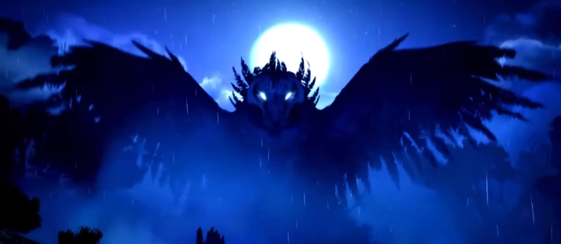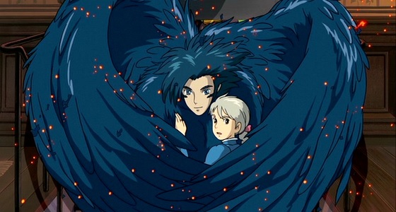
Composition
The composition of Ori and the Blind Forest as a whole is fairly simple because of it being a platformer but the camera seems to follow the landscape while zoomed out rather than zooming in on the player and moving the camera according to Ori’s movements, reinforcing that the landscape and elements within it were what the creator wanted the player to focus on and making it easier to play.
The more intricate shots are within the cutscenes so the player can pay attention to the scene rather than to the gameplay. In cutscenes, the composition changes drastically at dramatic plot points/scene establishing shots from the simple composition of a platformer game to a more cinematic perspective. This could be compared to Ghibli often taking breaks from the story to showcase scenery or atmospheric shots that build up the world the characters are living in, although these scenes can be simple, relaxed, and introspective such as the train scene from Spirited away.
The game follows the style of more intricate, detail focused Ghibli movies, such as Howl’s Moving Castle and Princess Mononoke. Movies like Spirited away have simpler landscapes, reserving more detail for more pivotal moments or locations such as the bathhouse and the surrounding village but Howl’s Moving castle has detail in scene after scene, possibly due to the nature of each story. Spirited away is much more slow paced and Howl’s Moving Castle is more chaotic.

Howl’s Moving Castle Spirited Away
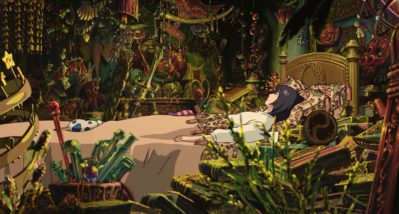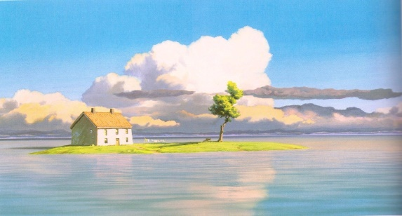
Colour:
The colours of Ori and the Blind Forest are dark for the most part, themed mainly around blue where the story is most peaceful because it is easy to look at. Where there is conflict or disruption of the peaceful setting, the colours tend to be either darker than usual or purple. Ori and the Blind Forest could possibly use purple because the theme is centred on blue and going directly to red as the obvious choice for ‘Danger’ is too much of a jump, so shifting the palette towards red while keeping the theme seemed more appropriate. Ghibli uses purple to express negativity in the same way, possibly because it is typically seen as rich and extravagant, it could appear conflicting to the theme of nature and harmony. Ghibli also uses purple to symbolise uncleanliness such as in sludge or swamps and evil or corruption.
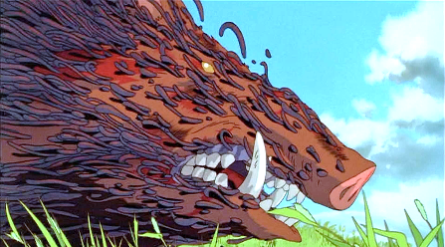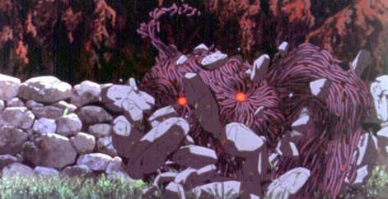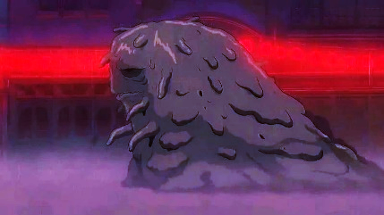
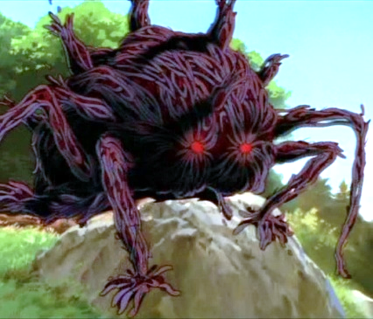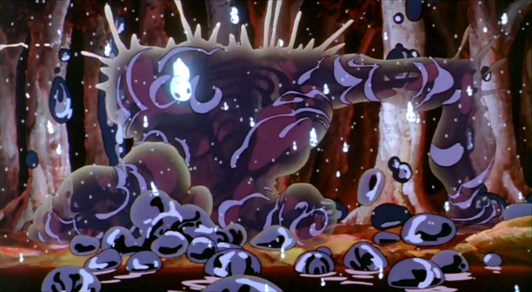
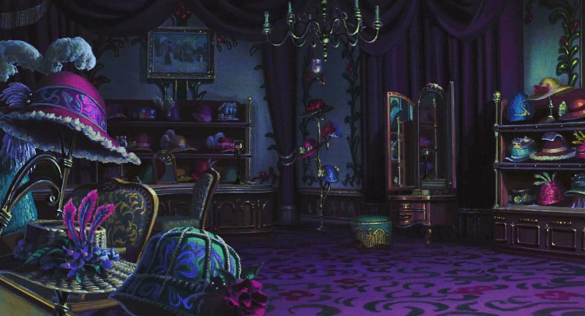
Animation
The game combines 3d techniques and puts them in a 2d setting, making the animation look smooth and the characters look as if they have volume despite being in a platformer. This also gives the creators an opportunity to use more of the detail they need to give the game the specific style it has. The shading and lighting can be made to look very realistic if it is the desired effect but for the most part, the art is stylized. The stylization is obvious in the gameplay and in objects such as the trees where there are only a few branches and the way that the game behaves like a 2D game even though everything looks partially 3D.
Ghibli uses a similar technique to create specific scenes that combine 2D and 3D elements, either because something would be too difficult to animate by hand or because it emphasizes the appeal of a scene. This is used in an early scene in Princess Mononoke, where snake-like creatures move around, overlapping each other in a very smooth looking way which may be harder to achieve using 2D animation. This is one of the few scenes that Ghibli uses CGI when it is seen as necessary because it doesn’t appear to match the hand drawn aesthetic of most of the movies.
https://gfycat.com/gifs/detail/infiniteamusingcowrie
In my opinion, Ghibli could inspire a lot of environments and ideas made in video games. Some settings within the movies could be used in level design to make playing more visual and interesting. Many settings within these movies are intricately and creatively designed and could be enjoyed in a completely different format as shown by Ori and the Blind Forest, which has the same whimsical quality of many films made by Studio Ghibli.

